

Practices for Secure Software Report

Table of Contents
Document Revision History 3
Client 3
Instructions 3
Developer 4
1. Algorithm Cipher 4
2. Certificate Generation 4
3. Deploy Cipher 4
4. Secure Communications 4
5. Secondary Testing 4
6. Functional Testing 4
7. Summary 4
8. Industry Standard Best Practices 4

Document Revision History

Version | Date | Author | Comments
1.0 | 6/21/2026 | Neo Huynh | Final Submission

Client



Developer
Neo Huynh

Algorithm Cipher

Artemis Financial is a consulting company that develops individualized financial plans for its customers, which include savings, retirement, investment, and insurance. The most likely culprit for hacking and attacking Artemis Financial are those attempting to access the information stored, therefore the first and strongest line of security would include an encryption algorithm cypher. Encrypting the information will cause the information to be practically impossible to decipher without the key, thus keeping the data secure. For the algorithm cipher, I would recommend the highest and reliable level of security with AES-256 for encryption and SHA-256 for hashing. AES-256 encrypts using a secret encryption key with a bit-length of 256, which prevents brute force attempts and renders the data nonsense without the key. SHA-256 is ideal when used alongside AES-256, since it converts input data into a 256 bit-length hash value. SHA-256 produces an output of 256 no matter what, therefore allowing Artemis Financial to verify if the transmitted data has been tampered with. A secure hash also has collision resistance to prevent two different inputs from having the same hash value, as well as preimage resistance to prevent reverse engineering the hash and deterministic output to have the same input produce the same hash value. AES-256 and SHA-256 will both utilize random numbers to prevent predictable output for preimage resistance as well. This is important because the same key is used for both encryption and decryption, known as a symmetric key. The random numbers will be generated using Java’s random number generator. It is important that Artemis Financial utilizes AES-256 for modern day encryption due to its security from encryption standards like Data Encryption Standard (DES). DES was the old standard because it functioned similarly to AES-256, encrypting data using a key, but became outdated due to the introduction of newer computers that were able to brute-force the key due to its bit-length of 56. Additionally, AES-256 is not only the front runner to security, but also other methods such as SHA-256 to hash and secure data sent between two clients, and other methods like authentication and asymmetric encryption.

Certificate Generation
Insert a screenshot below of the CER file.

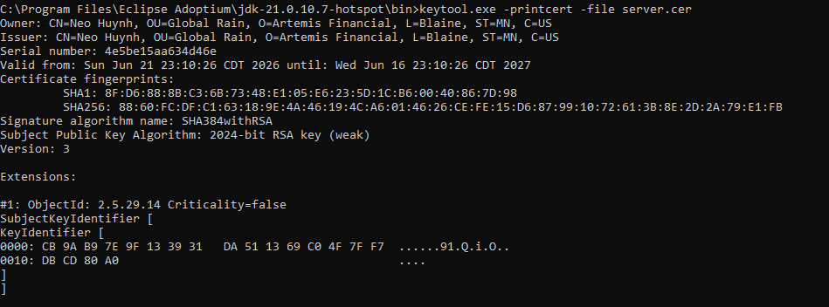

Deploy Cipher
Insert a screenshot below of the checksum verification.

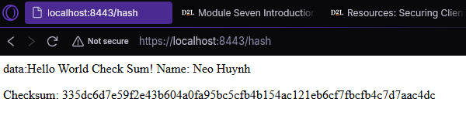

Secure Communications
Insert a screenshot below of the web browser that shows a secure webpage.

The page isn’t secure because my cert was self signed.

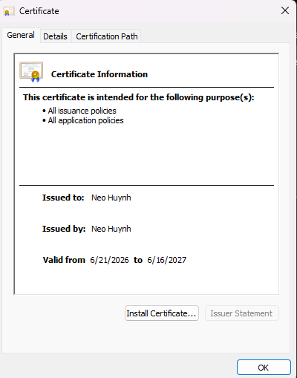

Secondary Testing
Insert screenshots below of the refactored code executed without errors and the dependency-check report.
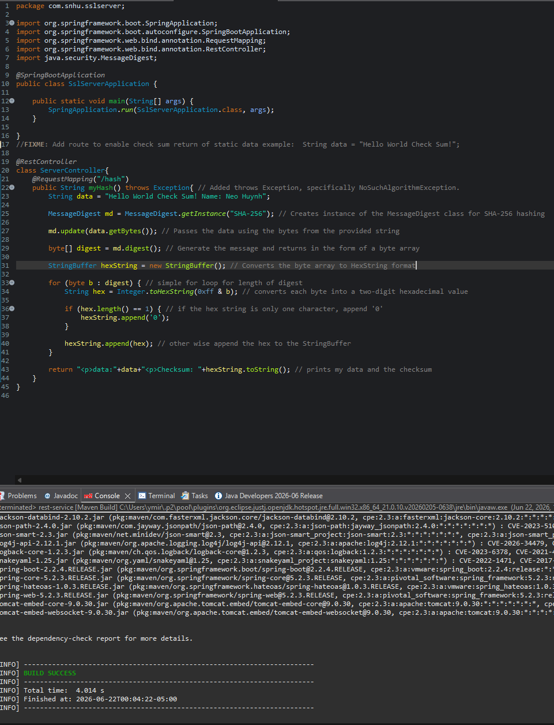
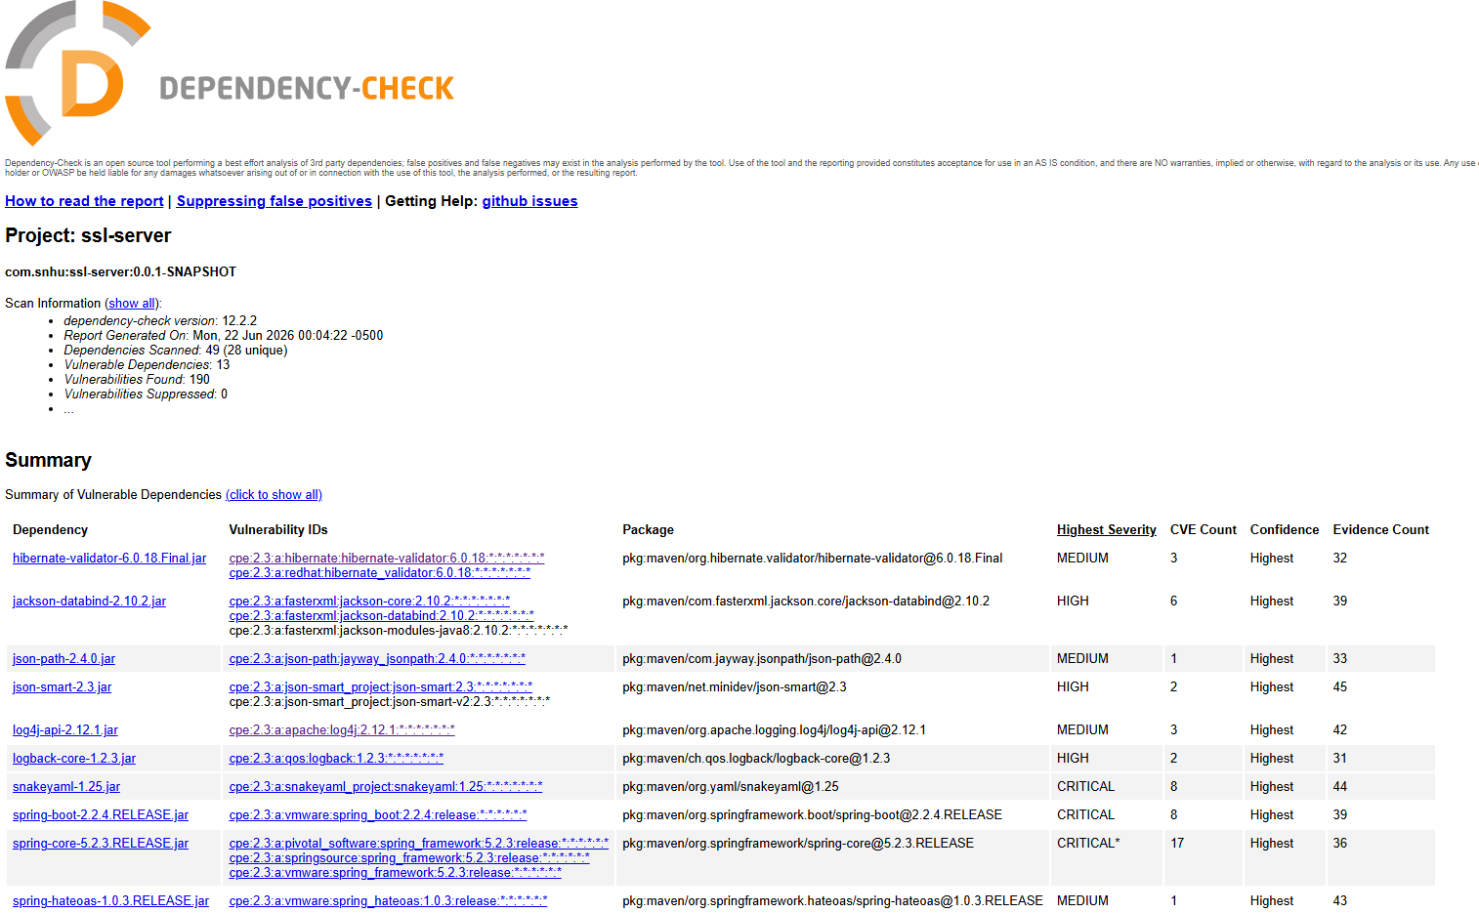

Functional Testing
Insert a screenshot below of the refactored code executed without errors.

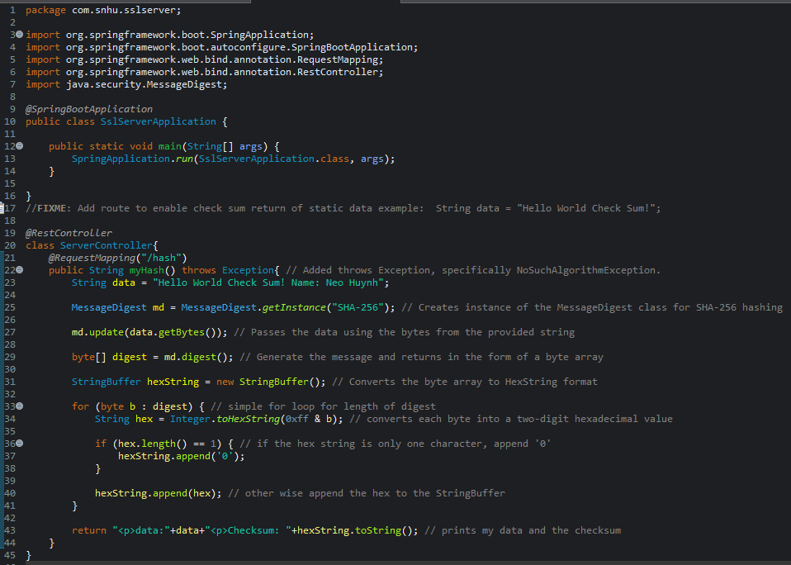

Summary

The code has been refactored, and I have encapsulated the program in a RestController, using /hash to remap. The ServerController class works by creating a SHA-256 checksum using Java’s MessageDigest class. SHA-256 works by creating a 256 bit-length hash and has improved security due to the very small chance of collisions. It also works to try and match the vulnerability assessment diagram by first taking input, having secure API interactions, encrypting, distributing, and is encapsulated.

To add more layers of security, make sure to consistently run dependency checks weekly to stay on top of new and discovered vulnerabilities, keeping company data and user information secure and safe. It is important to note that AES-256 has not been developed yet, but for future use can be another layer of security on top of SHA-256 to further secure data from attackers and for customers.

Industry Standard Best Practices

Industry Standard best practices for secure coding to mitigate known security vulnerabilities include using the SHA-256 algorithm created with Java’s MessageDigest class to create strong encryptions. By encrypting data end-to-end, it ensures that traffic, even if it is intercepted and received by the wrong person, cannot be deciphered and abused. This also secures the data and processing on the server side for the same reason.

For Artemis Financial, SHA-256 is incredibly important for security and data protection, keeping data encrypted during transit and rest ensures that user data and company information is intact and safe. Applying industry best practices improves Artemis Financial as a consulting company by reducing the risk of data tampering and unauthorized access while also increasing trustworthiness amongst customers and security expectations.

